Tutorial – 9.3

**Aim:** Any integer in input through keyboard. Write a shell script to find out whether it is an odd number or even number.

**Code:**echo "Enter the Number"

read n

r=`expr $n % 2`

if [ $r -eq 0 ] then

echo "$n is Even number"

else

echo "$n is Odd number"

fi

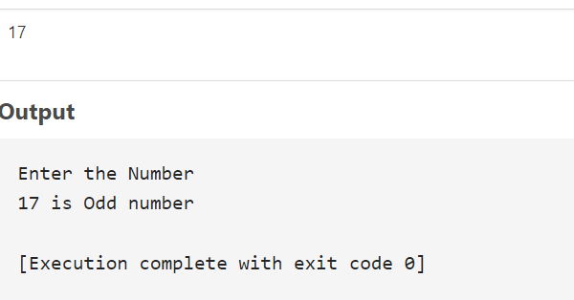**Output:**